**PIZZA SALES SQL QUERIES**

**A. Calculating KPI’s**

**1. Total Revenue:**

SELECT SUM(total_price) AS 'Total Revenue' FROM pizza_sales;

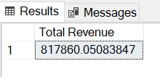

**2. Average Order Value**

SELECT SUM(total_price) / COUNT(DISTINCT order_id) AS 'Average Order Value' FROM pizza_sales;

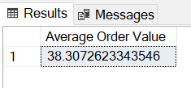

**3. Total Pizzas Sold**

SELECT SUM(quantity) AS 'Total Pizzas Sold' FROM pizza_sales;

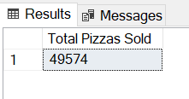

**4. Total Orders**

SELECT COUNT(DISTINCT order_id) AS 'Total Orders' FROM pizza_sales;

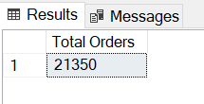

**5. Average Pizzas Per Order**

SELECT CAST(CAST(SUM(quantity) AS DECIMAL(10,2)) /

CAST(COUNT(DISTINCT order_id) AS DECIMAL(10,2)) AS DECIMAL(3,2))

AS 'Average Pizzas Per Order'

FROM pizza_sales;

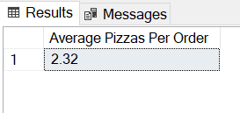

**B. Daily Trend for Orders**

SELECT DATENAME(WEEKDAY, order_date) AS Weekdays,

COUNT(DISTINCT order_id) AS Orders

FROM pizza_sales

GROUP BY DATENAME(WEEKDAY, order_date), DATEPART(WEEKDAY, order_date)

ORDER BY DATEPART(WEEKDAY, order_date);

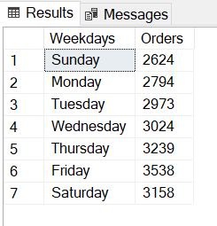

**C. Monthly Trend for Orders**

SELECT DATENAME(MONTH, order_date) AS Months,

COUNT(DISTINCT order_id) AS Orders

FROM pizza_sales

GROUP BY DATENAME(MONTH, order_date), DATEPART(MONTH, order_date)

ORDER BY DATEPART(MONTH, order_date);

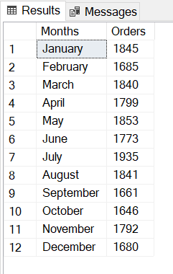

**D. % of Sales by Pizza Category**

SELECT pizza_category,

CAST(SUM(total_price) AS DECIMAL(10,2)) AS revenue,

CAST(SUM(total_price) / (SELECT SUM(total_price) FROM pizza_sales) * 100 AS DECIMAL(4,2)) AS percentage

FROM pizza_sales

GROUP BY pizza_category

ORDER BY 2 DESC;

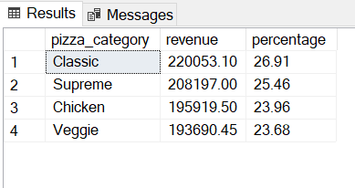

**E. % of Sales by Pizza Size**

SELECT pizza_size,

CAST(SUM(total_price) AS DECIMAL(10,2)) AS revenue,

CAST(SUM(total_price) / (SELECT SUM(total_price) FROM pizza_sales) * 100 AS DECIMAL(4,2)) AS percentage

FROM pizza_sales

GROUP BY pizza_size

ORDER BY 2 DESC;

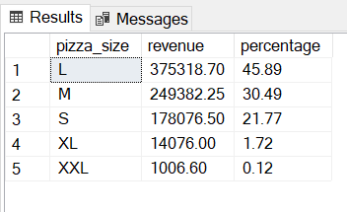

**F. Total Pizzas Sold by Pizza Category**

SELECT pizza_category,

SUM(quantity) AS total_quantity

FROM pizza_sales

GROUP BY pizza_category

ORDER BY 2 DESC;

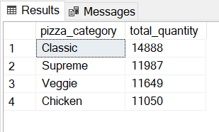

**G. Best Sellers**

**1. Top 5 Pizzas by Revenue:**

SELECT TOP 5 pizza_name,

SUM(total_price) AS revenue

FROM pizza_sales

GROUP BY pizza_name

ORDER BY 2 DESC;

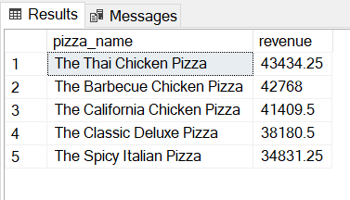

**2. Top 5 Pizzas by Quantity:**

SELECT TOP 5 pizza_name,

SUM(quantity) AS quantity

FROM pizza_sales

GROUP BY pizza_name

ORDER BY 2 DESC;

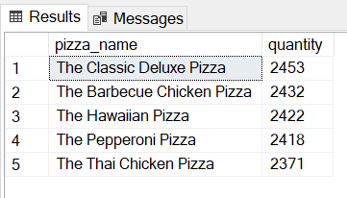

**3. Top 5 Pizzas by Total Orders:**

SELECT TOP 5 pizza_name,

COUNT(DISTINCT order_id) AS total_orders

FROM pizza_sales

GROUP BY pizza_name

ORDER BY 2 DESC;

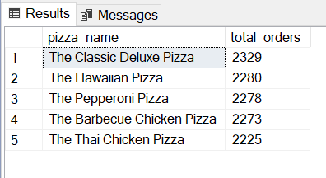

**H. Worst Sellers**

**1. Bottom 5 Pizzas by Revenue:**

SELECT TOP 5 pizza_name,

SUM(total_price) AS revenue

FROM pizza_sales

GROUP BY pizza_name

ORDER BY 2;

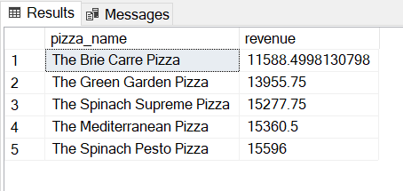

**2. Bottom 5 Pizzas by Quantity:**

SELECT TOP 5 pizza_name,

SUM(quantity) AS quantity

FROM pizza_sales

GROUP BY pizza_name

ORDER BY 2;

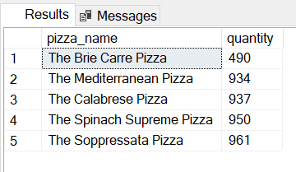

**3. Bottom 5 Pizzas by Total Orders:**

SELECT TOP 5 pizza_name,

COUNT(DISTINCT order_id) AS total_orders

FROM pizza_sales

GROUP BY pizza_name

ORDER BY 2;

